Tugas Praktikum 19

1. <!DOCTYPE html>
2. <html>
3. <head>
4. <title>Demo Task HTML</title>
5. </head>
6. <body>
7. <div>
8. <h1>My Book</h1>
9. <h2>Social Media Kita Bersama</h2>
10. <p>Bersama kita membangun ekosistem yang sehat dan budaya saling berbagi yang menyenangkan</p>
11. <h2>Benefit Join di My Book</h2>
12. <ul>
13. <li>Social Media yang Nyaman dan mMudah</li>
14. <li>Fitur yang cangggih dan menggunakan teknologi terkini</li>
15. <li>Dibuat oleh calon development full-stack masa depan</li>
16. </ul>
17. <h2>Cara Bergabung</h2>
18. <ol>
19. <li>Mengujungi Website ini</li>
20. <li>
21. Mendaftar di
22. <a href="form.html">Form Sign Up</a>
23. </li>
25. <li>Selesai</li>
26. </ol>
27. </div>
28. </body>
29. </html>

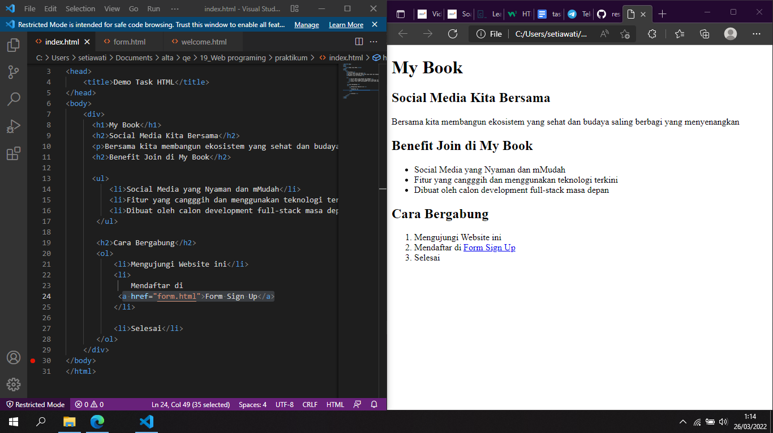

2. <!DOCTYPE html>

<html>

<head>

    <title>Form Sign Up</title>

</head>

<body>

    <div>

      <h1>Buat Account Baru</h1>

      <h2>Sign Up Form</h2>

      Full name:

      <br/>

      <input id="full-name"  name="nama"

      type="text"/>

      <br/>

      <br/>

      Last name:

      <br/>

      <input id="password" name="password"

      type="password"  />

      <br/>

      <br/>

      Gender:

      <br/>

      <input type="radio" id="male"

      name="male"value="laki-laki" />

      <label for="male">Male</label>

      <br/>

      <input type="radio" id="female"

      name="female" value="perempuan" />

      <label for="male">Female</label>

      <br/>

      <input type="radio" id="other"

      name="other" value="other" />

      <label for="male">Other</label>

      <br/>

      <br/>

      Nasionality:

      <br/>

      <select name="negara" >

          <option value="Indonesian"> Indonesia</option>

          <option value="Malaysia">Malayisa</option>

          <option value="Singapura">Singapura</option>

        </select>

        <br />

        <br />

      Language Spoken:

      <br />

      <input type="checkbox" name="bahasa_indonesia" /> Bahasa Indonesia

      <input type="checkbox" name="english" /> English

      <input type="checkbox" name="other" /> Other

      <br />

      <br />

      Bio:

      <br />

      <textarea name="bio" rows="5" cols="20">

      </textarea>

      <br />

      <form action="file:///C:/Users/setiawati/Documents/alta/qe/19_Web%20programing/praktikum/welcome.html">

       <input type="submit" value="Sign UP" />

       </form>

    </div>

</body>

</html>

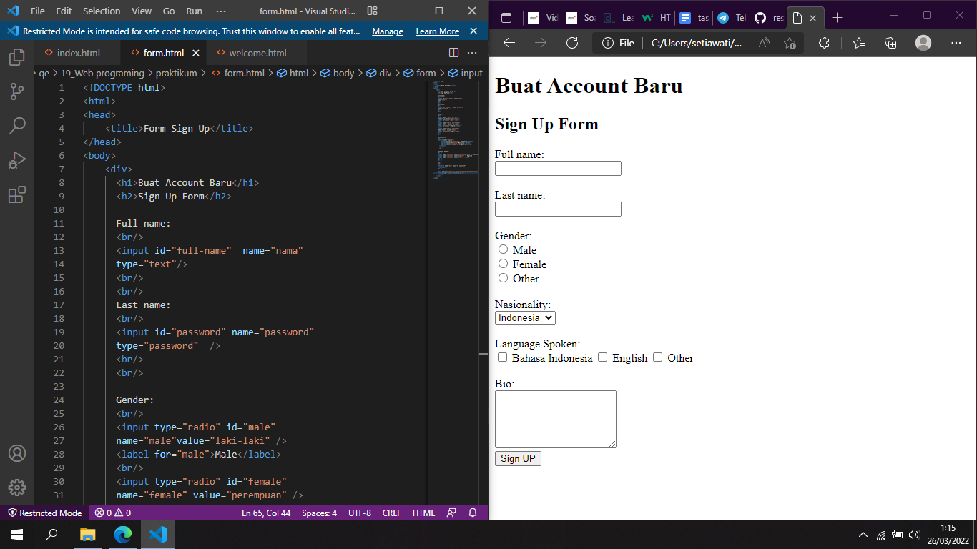

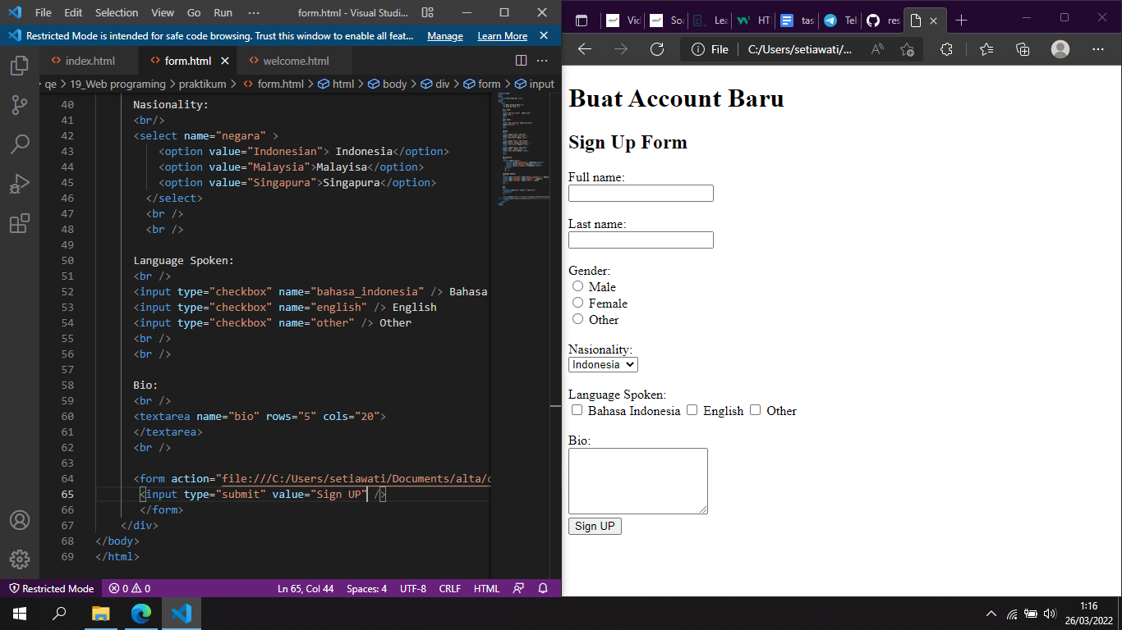

3. <!DOCTYPE html>

<html>

<head>

    <title>Welcome</title>

</head>

<body>

    <div>

      <h1>SELAMAT DATANG</h1>

      <h3>Terimakasih telah bergabung di MyBook. Social media kita bersama!</h3>

    </div>

</body>

</html>

